1. Successfully to collect the sensor data and save it in Microsoft Azure in real time and it is in JSON format

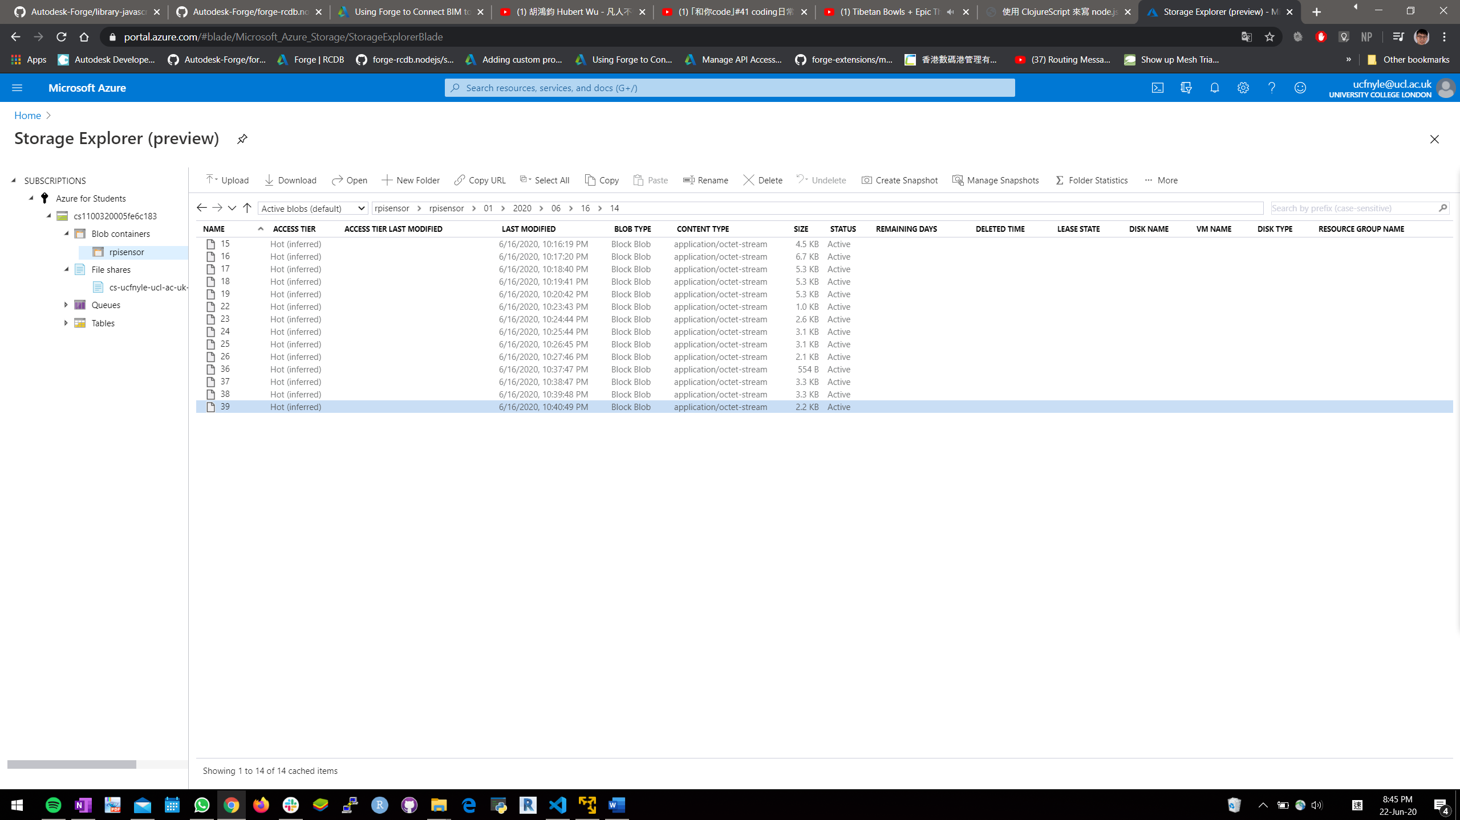

2. Successfully to display data in BIM360 model



Next Step

- Starting on writing the part of introduction + LitReview + methodology

- Continue to get the technical skills and fine tune the model